https://dataedo.com/blog/what-is-metadata-examples:

What is Metadata - 9 Examples

Contents
Typical Metadata 2
A Photo 2
A Book 3
A Blog Post 3
Email 4
Electronic Document 5
A Spreadsheet 6
Computer Files 6
Web page 7
Paper Files 8
Learn more 8

Metadata is simply data about data. It means it is a description and context of the data. It helps to organize, find and understand data. Here are a few real world examples of metadata:

Typical Metadata
Those are some typical metadata elements:
- Title and description,
- Tags and categories,
- Who created and when,
- Who last modified and when,
- Who can access or update.

A Photo

Every time you take a photo with today's cameras a bunch of metadata is gathered and saved with it:
- date and time,
- filename,
- camera settings,
- geolocation.

A Book
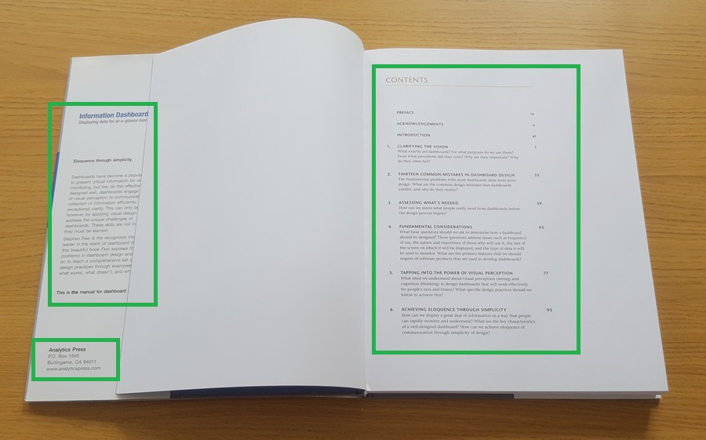
Each book has a number of standard metadata on the covers and inside. This includes:
- a title,
- author name,
- publisher and copyright details,
- description on a back,
- table of contents,
- index,
- page numbers.

A Blog Post

Every blog post has standard metadata fields that are usually at before first paragraph. This includes:
- title,
- author,
- published time,
- category,
- tags.

Email
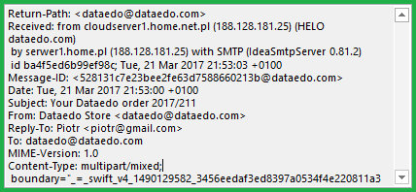
Every email you send or receive has a number of metadata fields, many of which are hidden in the message header and not visible to you in your mail client. This metadata includes:
- subject,
- from,
- to,
- date and time sent,
- sending and receiving server names and IPs,
- format (plain text of HTLM),
- anti-spam software details.

Electronic Document
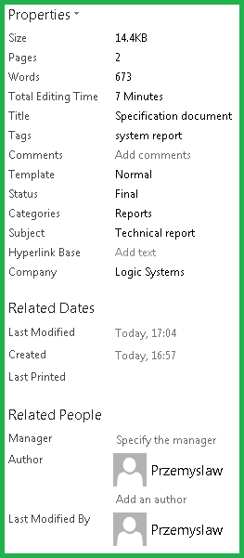
Every word processing software collects some standard metadata and enables you to add your own fields for each document. Typical fields are:
- title,
- subject,
- author,
- company,
- status,
- creation date and time,
- last modification date and time,
- number of pages.

A Spreadsheet
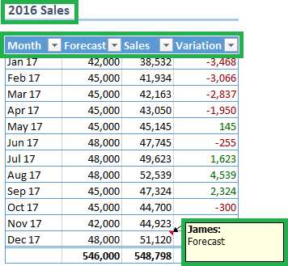
Spreadsheets contain a few metadata fields:
- tab names,
- table names,
- column names,
- user comments.

Computer Files
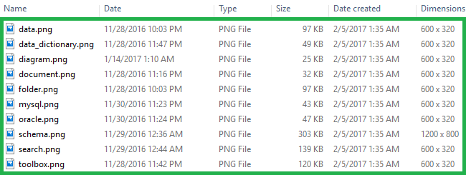
All the fields you see by each file in file explorer is actually metadata. The actual data is inside those files. Metadata includes:
- file name,
- type,
- size,
- creation date and time,
- last modification date and time.

Web page
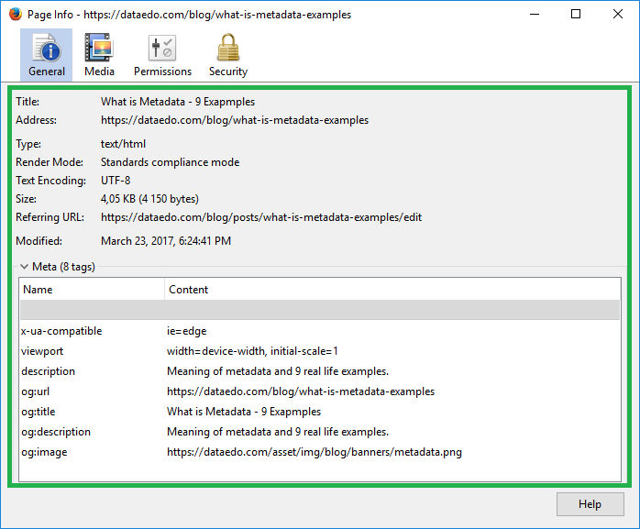
Every web page has a number of metadata fields:
- page title,
- page description,
- icon.

Paper Files

Paper document files have often administrative metadata that help manage documents. This might include:
- letter for files organized alphabetically,
- access control information ("classified" for instance),
- logos.

Learn more
- What is Data Dictionary
- Create a Data Dictionary with Dataedo

